CS 5764: Information Visualization

Homework 1 Sourabh Shetty

Link to full visualization: <http://i.imgur.com/nKMtPRE.jpg> (Doesn’t fit into a standard single page)

This is a rather simple example of information visualization that I see in my day-to-day life. I follow a community on reddit that discusses the massively popular TV show, Game of Thrones. They frequently have post-episode surveys and collect information about how each person enjoyed different aspects of the episode. Initially, the results of these were represented in purely text-based tables, and then later in pie charts and bar graphs.

Neither approach particularly elicited much excitement or engagement from the community at large. I myself would often ignore those posts and my eyes would glaze over the results without truly registering much of it. The pie charts and bar graphs were an improvement, but still not interesting enough for people to actually pay attention. That was until another user decided to help by making things more visual, and added the data along with stills from the show in a much easier to absorb format.

When you can see a picture of the exact character or moment being discussed, it helps contextualize the data in a much better way. You can immediately understand what each item refers to.

Even simple Yes/No questions are more engaging as a result:

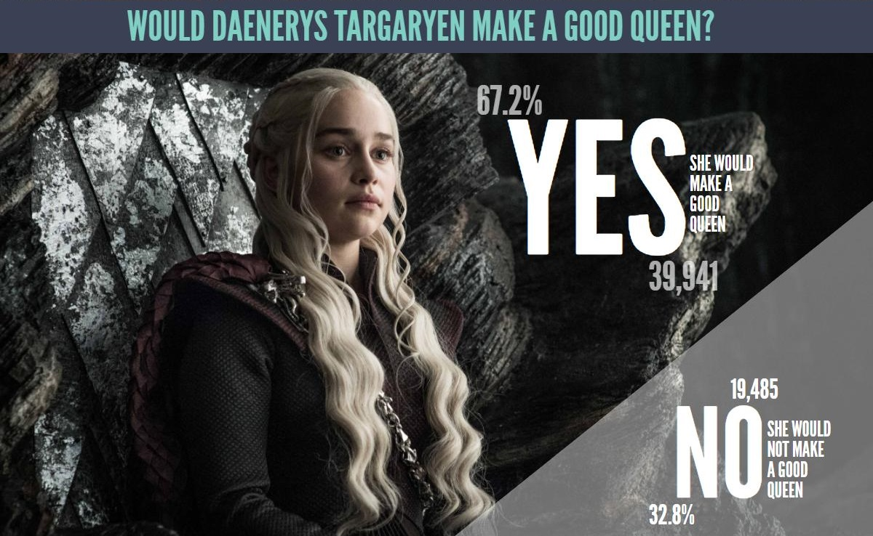

For each question, each answer only takes up space in the graphic in proportion to the number of respondants that voted for it, making it a more visually appealing evolution of the trusty old pie-chart.

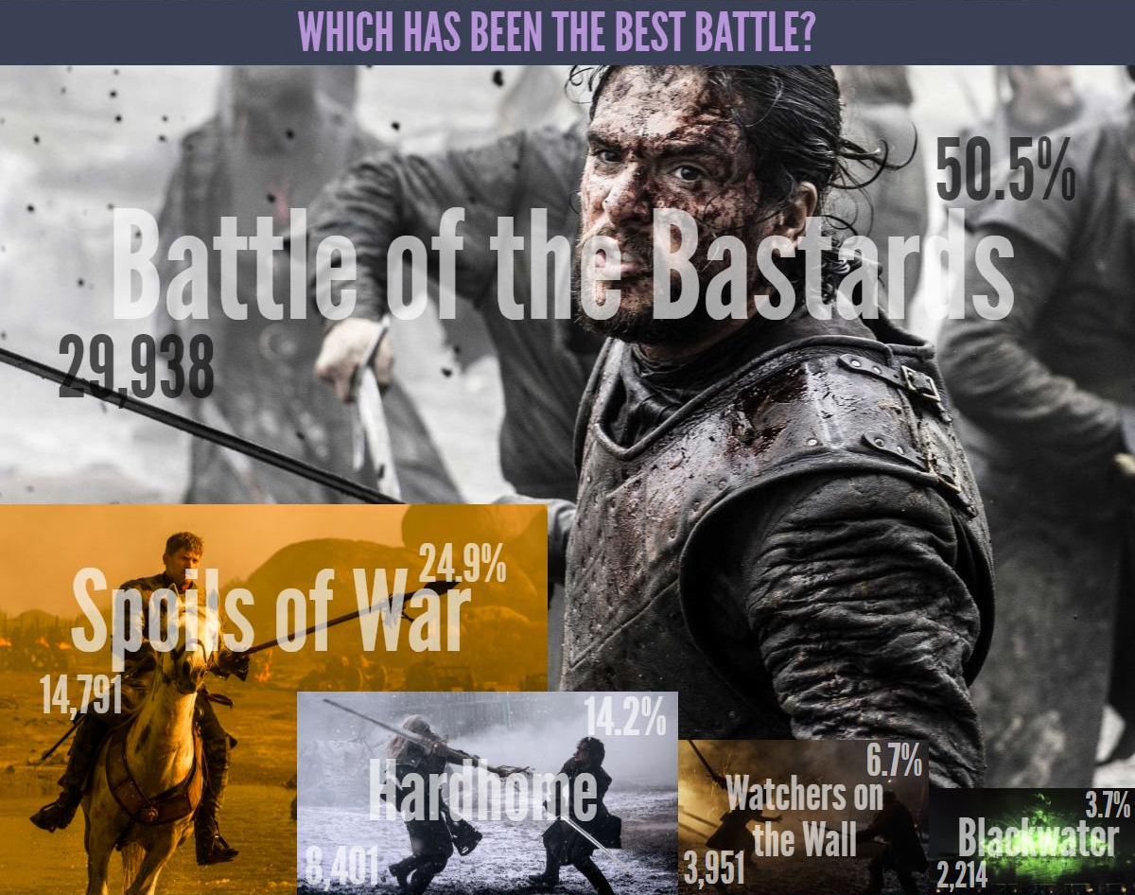

Among other things, it becomes immediately clear that despite the massive spectacle of the huge battle in this episode “Spoils of War”, viewers by and large still preferred the battle from the previous season episode “Battle of the Bastards” more, despite it not featuring any dragons.

Another thing that becomes clear is that despite the character of Daenerys Targaryen burning thousands of people to death, and causing harm to some likable main and supporting characters, she still enjoys the support of a majority of the viewerbase.

The graphic does a good job conveying exactly what percentage of people felt a certain way towards different events and characters after the episode. The exact number of people being listed also helps give the data some sort of scale.

Some of the color choices on the font and border is a bit suspect, but on the whole I found this to be an effective way to capture the attention of even the stereotypically low attention span having TV viewers.

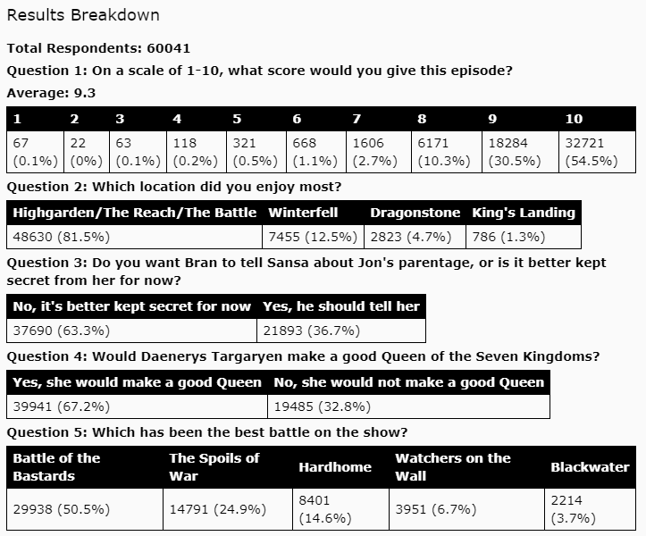

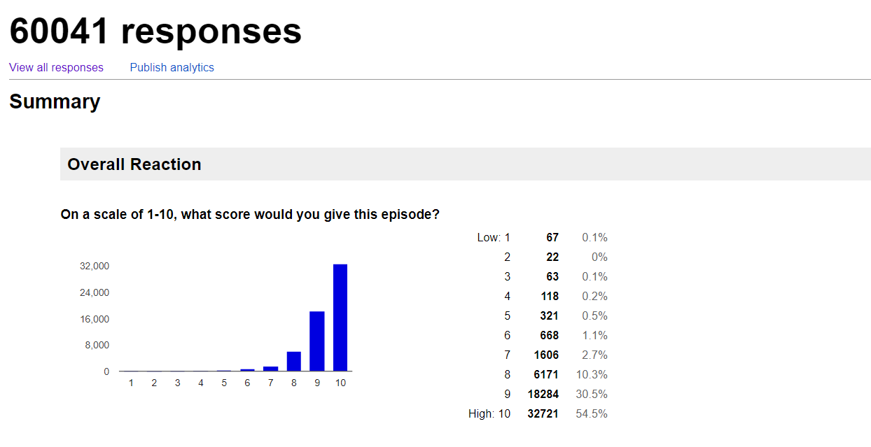

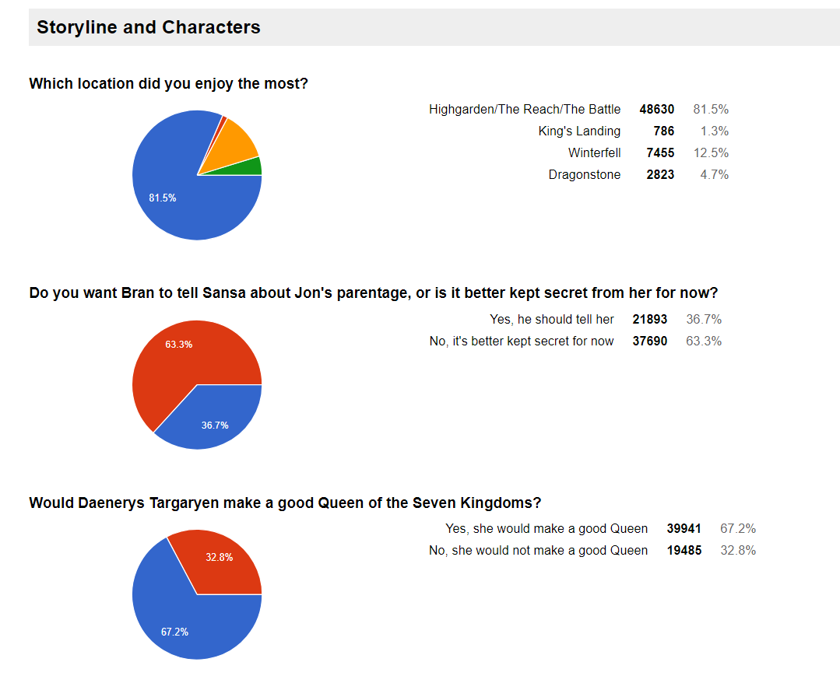

Sources:

Link to data in text form and further links to the visualizations: <https://www.reddit.com/r/gameofthrones/comments/6ssvwj/s7e4_postepisode_survey_results_s7e4_the_spoils/>

Poll created and data collected by: <https://www.reddit.com/user/BWPhoenix>

Full graphic created by: <https://www.reddit.com/u/AviatorRossy>